Gym Exercises
Student’s Name
Institution
Date

Gym Exercises
Lunges
The exercise has the benefit of stimulating functional movement and increased the strength of a person’s legs as well as glutes. It is done when a person stands with their feet shoulder-width spread apart while the arms are down at their side. You then make a step forward using the right leg as you bend the right and stop when the thing is parallel to the surface.
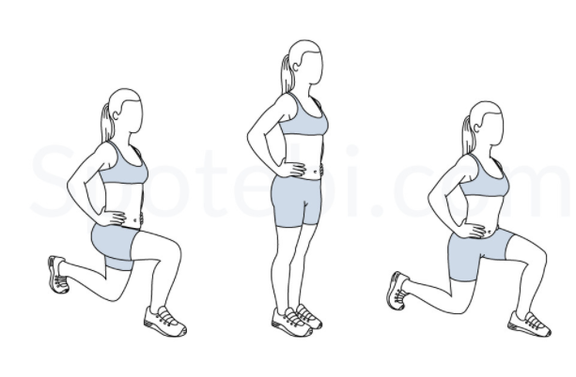
Figure 1: Lunges
Pushups
This exercise has myriad benefits like building strength in the muscles pectoral and abdominal muscles. It helps strengthen the triceps along with the shoulder (Van Den Tillaar, & Ball, 2020). It involves getting down on all fours while pacing the hands a little wider than the shoulders. You then straighten the arms and legs and lower the body to the ground and raise it back repeatedly.
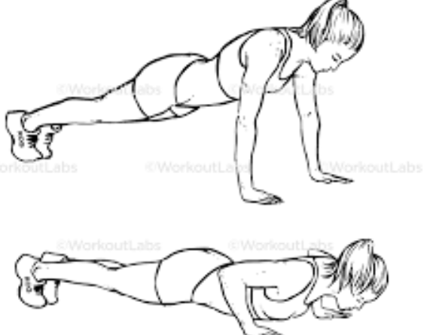
Figure 2: Pushups
Dumbbell rows
The exercise helps strengthen the muscles in the upper body. Also, it has the benefit of building a stronger back and strengthens the shoulder, core as well as upper arms. It is executed by following various steps. Firstly, a person has to have a dumbbell in every hand. He or she has to bend forward at the waist and ensure that the back is at a 45-degree angle to the floor. Then start with the right arm yank the weight straight up towards the chest.
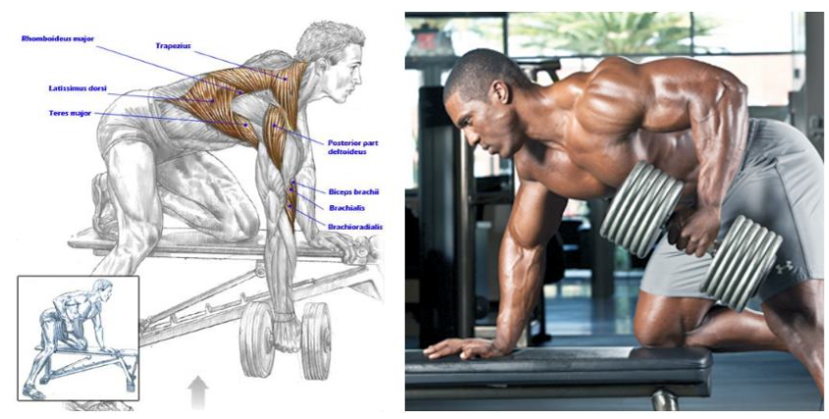
Figure 3 Mastering The Dumbbell Row
Squats
The exercise helps increase lower body as well as core strength. Additionally, they improve the flexibility of the lower back and hips. Squats have various benefits. Foremost, they help burn excess calories in the body. Besides, they boost one’s athletic ability and strength (Boffey, Clark, & Fukuda, 2021). It is done when a person stands straight with their chest somewhat wider compared to shoulder-width apart with the arms positioned at the sides. Push your hips back while bending your knees like a person taking a seat. The person has to brace their core while ensuring that their chest and chin are kept up.
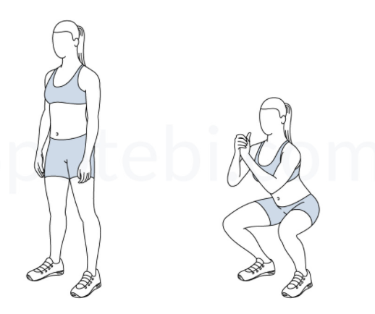
Figure 4: Squats
Single-leg deadlifts
This is an exercise that ensures stability along with the leg strength of an individual. In essence, it challenges one’s balance. It is beneficial since it helps strengthen and tone the butt muscles. Also, it improves one’s balance. The exercise is done through various steps. Firstly, a person begins by standing with a dumbbell clutched in the right hand while the knees are a little bent. Secondly, the person has to begin kicking their left leg straight back behind and lower the dumbbell towards the floor. After reaching a comfortable height with their left leg, a person has to return slowly to the starting position.
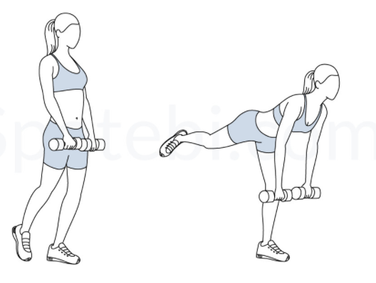
Figure 5: Single Leg Deadlift
Standing overhead dumbbell presses
This is an exercise that utilizes various joints and muscles. It is essential for the strengthening of the shoulders, the upper back as well as the core. Some of its benefits strengthening the shoulder, trapezius, and triceps muscles (Johnsen, & van den Tillaar, 2021). The procedure for doing the exercise is simple. Firstly, a person has to stand with their feet shoulder-width apart or staggered and pick a recommended set of dumbbells. Then move the weights above with the upper arms being parallel to the ground or surface. The person has to brace their core and start pushing up till their arms are completely extended above their head.
Burpees
It is an exercise that ensures a whole-body workout. It helps in the strengthening and toning of the muscles in the legs, buttocks, arms, chest as well as shoulders. Furthermore, it has the benefit of building muscle strength and endurance of the lower and upper body. It is done by first standing upright while the feet shoulder-width apart as the arms are down to the sides. Squat with your hands out in front. Then pop your legs straights back into a pushup position when your hands reach the ground. A person has to get his or her feet closer to their hands.
Glute Bridge
The exercise helps work the hamstrings, lower back, abs as well as glutes (Tobey, & Mike, 2018). It has important benefits to the body. For instance, it strengthens a person’s core muscles. The glute bridge exercise follows a series of steps. It starts when a person lies on their back with the knees bent while the arms straights on the sides as the palms face down. Raise the hips off the floor by clutching the core, glutes along with hamstrings.
Planks
The exercise helps strengthen the core and aid the metabolic rate of the body. Moreover, it has various benefits such as reducing back pain and improving one’s posture. It can be done by beginning in a pushup position. A person has to brace his or her chin while gazing in front of their hands. He or she has to take deep controlled breaths and maintain tension through the entire body to engage the muscles of the body.
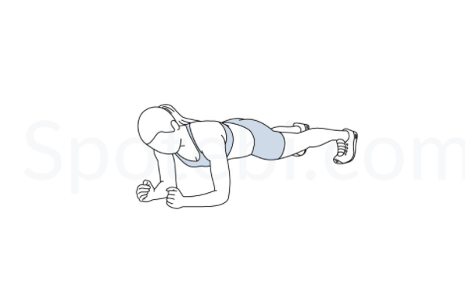
Figure 6: Planks
Side pranks
It helps strengthen the core and improve balance. Additionally, it has myriad benefits such as strengthening legs, arms, and waists. The steps for undertaking the exercise include lying on one’s right side with the left leg placed on top of the right leg. Then a person should contract their core to stiffen the spine and lift their hips and knees away from the floor. They have to return to start in a precise manner.

References
Boffey, D., Clark, N. W., & Fukuda, D. H. (2021). Efficacy of Rest Redistribution During Squats: Considerations for Strength and Sex. The Journal of Strength & Conditioning Research, 35(3), 586-595.
Johnsen, E., & van den Tillaar, R. (2021). Effects of training frequency on muscular strength for trained men under volume matched conditions. PeerJ, 9, e10781.
Tobey, K., & Mike, J. (2018). Single-leg glute bridge. Strength & Conditioning Journal, 40(2), 110-114.
Van Den Tillaar, R., & Ball, N. (2020). Push-ups are able to predict the bench press 1-RM and constitute an alternative for measuring maximum upper body strength based on load-velocity relationships. Journal of Human Kinetics, 73, 7.

